Q3 m5
What I know
_____ 1. Who first proposed that matter is composed of tiny, indivisible particles?
a. Aristotle
c. Democritus
b. Dalton
d. Rutherford

_____ 2. Who is the scientist credited for the discovery of electron in his experiment
using cathode ray tube?
a. Bohr
c. Democritus
b. Dalton
d. Thomson

_____ 3. Who is the scientist credited for the discovery of the positive central core of an atom using emission of alpha particles in a thin sheet of gold foil?
a. Dalton
c. Rutherford
b. Democritus
d. Thomson

_____ 4. What is the positively charged subatomic particle of an atom?
a. electron
c. nucleus
b. neutron
d. proton

_____ 5. What is a fairly heavy particle that has no net charge?
a. electron
c. nucleus
b. neutron
d. proton

_____ 6. What does the atomic number of an element indicate?
a. electrons in the nucleus
c. neutron plus the number of protons
b. neutrons in the nucleus
d. protons in the nucleus
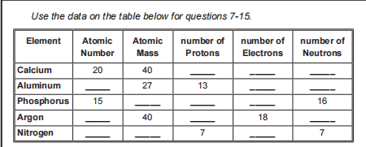
If kaya ilagay to palagay kasi di masasgutan ung 7 - 15

_____ 7. What is the number of neutron in calcium?
a. 0
b. 20
c. 40
d. 60
_____ 8. What is the number of neutron in aluminum?
a. 0
b. 13
c. 14
d. 15
_____ 9. What is the atomic number of aluminum?
a. 13
b. 14
c. 27
d. 40
_____ 10. What is the atomic mass of phosphorus?
a. 15
b. 16
c. 30
d. 31
_____ 11. What is the number of proton in phosphorus?
a. 15
b. 16
c. 30
d. 31
_____ 12. What is the number of proton in argon?
a. 18
b. 22
c. 40
d. 58
_____ 13. What is the number of neutron in argon?
a. 18
b. 22
c. 40
d. 58
_____ 14. What is the atomic mass of nitrogen?
a. 0
b. 7
c. 14
d. 21
_____ 15. What is the atomic number of nitrogen?
a. 0
b. 7
c. 14
d. 21

Independent act 1

1. It is the positively charged particle of an atom.
2. He used alpha particles in his experiment with a thin sheet of gold foil and
discovered a positively charge nucleus at the center of an atom.
3. Erwin Schrödinger believed that electrons act as waves; he illustrated electrons
as ________ surrounding the nucleus.
4. It is the model created by John Dalton where he described atoms as tiny balls.
5. It is the atomic model similar to a cookie where the electrons are like scattered
chocolate chips.
6. He stated that electrons move around in orbit of fixed size and energy.
7. It is the negatively charged particle of an atom.
8. It is the subatomic particle that has no net charge.
9. It is similar to a nut and is located at the center of the atom.
10. It is a Greek word which means indivisible.

Answer:
1. Proton
2. Ernest Rutherford
3. Cloud
4. Solid Sphere
5. Plum Pudding
6. Neils Bohr
7. Electron
8. Neutron
9. Nucleus
10. Atomos

Assessment
_____ 1. It is the subatomic particle that mainly contributes to the mass of an atom.
a. electron
c. proton and electron
b. proton
d. proton and neutron

_____ 2. The number of electrons in a neutral atom is equal to ________.
a. atomic mass
c. proton
b. neutron
d. proton and neutron

_____ 3. It is the subatomic particle that has no net charge.
a. electron
c. nucleus
b. neutron
d. proton

_____ 4. It is the subatomic particle found inside the nucleus.
a. neutron
c. proton and electron
b. proton
d. proton and neutron

_____ 5. It is the atomic model created by Ernest Rutherford experimenting with a thin
sheet of gold foil.
a. Nuclear model
c. Plum Pudding model
b. Planetary model
d. Quantum model

_____ 6. He is the scientist behind the discovery of neutron.
a. Erwin Schrödinger
c. John Dalton
b. James Chadwick
d. Neils Bohr
_____ 7. He is the scientist behind the discovery of electron.
a. Ernest Rutherford
c. John Dalton
b. Erwin Schrödinger
d. Joseph John Thomson
_____ 8. He is the scientist who stated that atoms of different elements are unique.
a. Ernest Rutherford
c. John Dalton
b. Erwin Schrödinger
d. Joseph John Thomson
_____ 9. It is the most accurate and widely accepted atomic model.
a. Nuclear model
c. Plum Pudding model
b. Planetary model
d. Quantum model
_____ 10. He is the scientist behind the discovery of protons.
a. Ernest Rutherford
c. John Dalton
b. Erwin Schrödinger
d. Joseph John Thomson

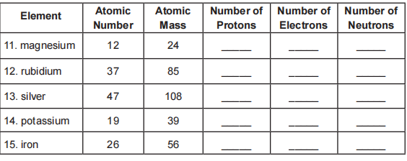
11. 12,12,12
12. 37, 37, 48
13. 47, 47, 61
14. 19,19,20
15. 26,26,30

